ITP4416 Written report

Task A
Step of setting up a database ~ phpmyadmin
- Set permissions 775 for assignment, src, mysql, docker-compose.yml and Dockerfile
- Docker compose up -d
- Log in phpmyadmin http://192.168.205.130:9801 :
server:db
Name:root
Password:skilltest
- Import sql database into the http://192.168.205.130:9801
- Go to http://192.168.205.130:9800 to show my website
Source code reference
AI tool :Gemini AI(Ver 1.5 Pro)
Prompt Used: “Generate a simple PHP web application containing an intentional, clear SQL Injection vulnerability in a GET-based search field. Include a database schema initialization for a users table. Ensure the layout leaves a prominent box at the top for Student Name, ID, and Class.”
Vulnerable Web Application: github
Url: https://github.com/byt3n33dl3/AzureSQLi
The PHP Documentation Group, "The mysqli::query method and fetch_assoc class references," PHP Manual, 2026. [Online]. Available: https://www.php.net/manual/en/mysqli.query.php

W3Schools, "PHP select data from MySQL (MySQLi Object-Oriented design structure)," W3Schools Online Web Tutorials, 2026. [Online]. Available: https://www.w3schools.com/php/php_mysql_select.asp

Task B
Normal Behavior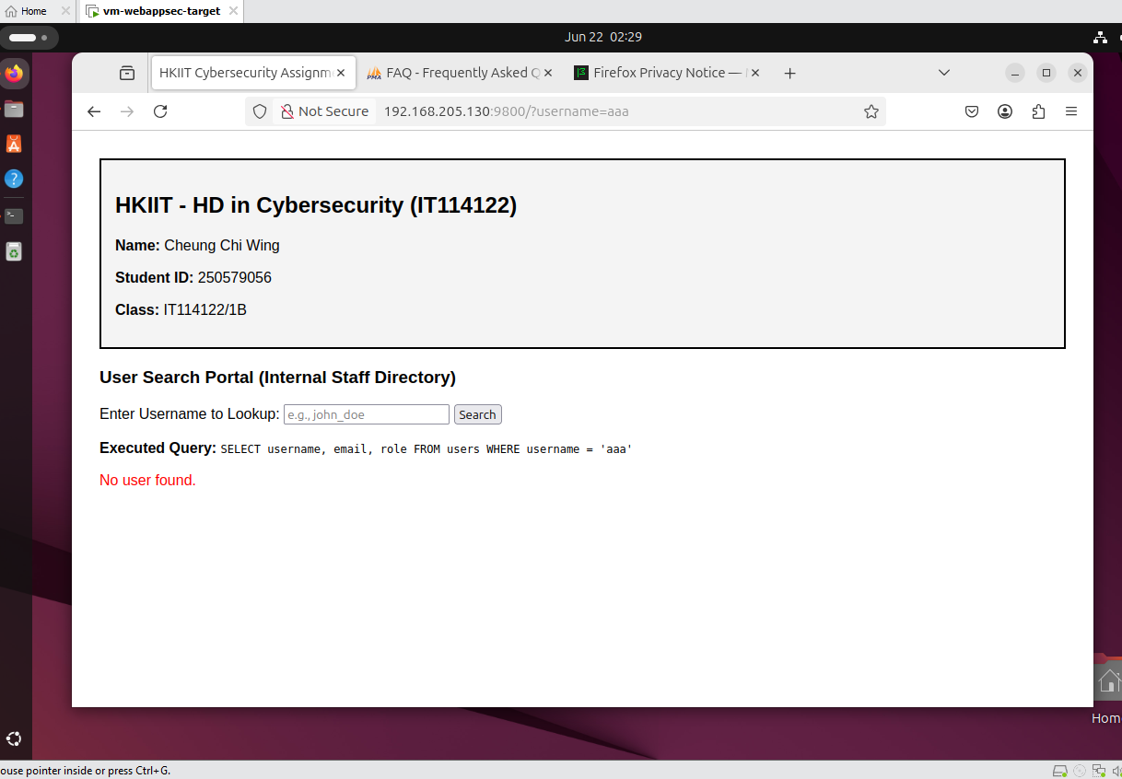 Random Input in the search bar

Authentication Bypass
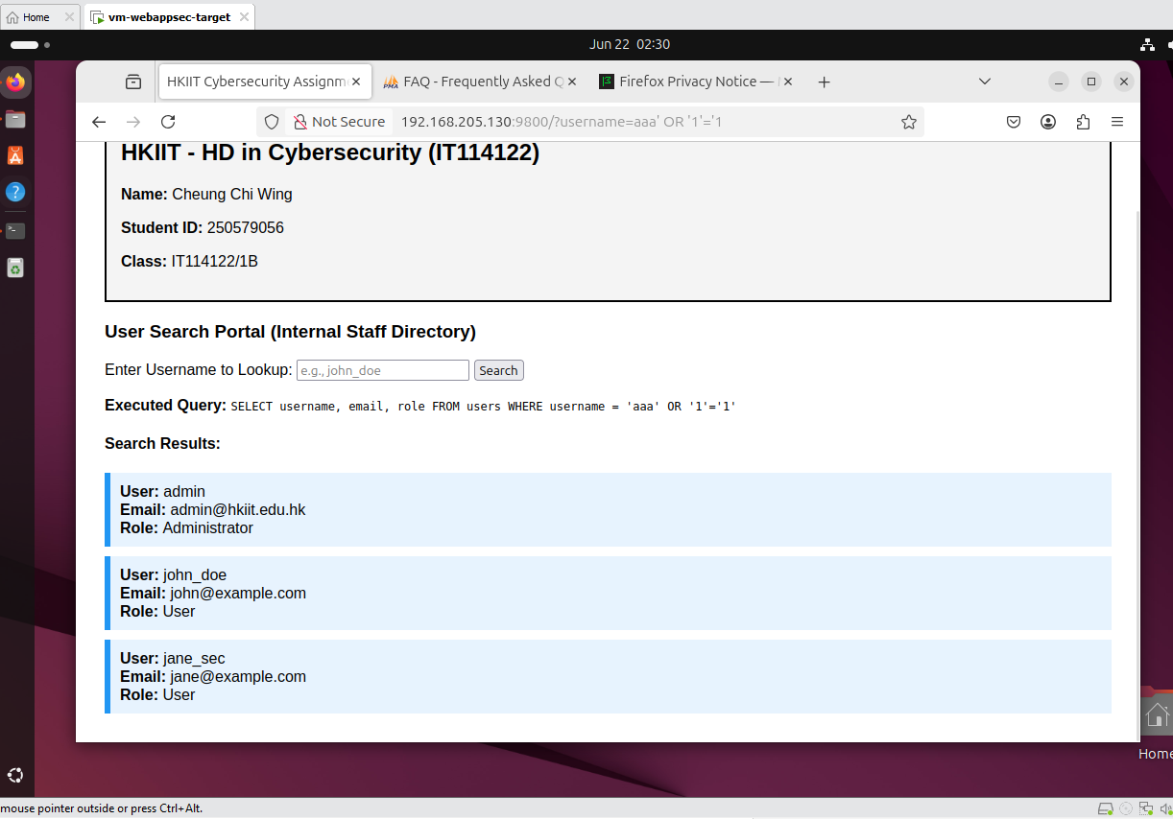 Payload in url :’ OR ‘1’=’1
Get Information about database
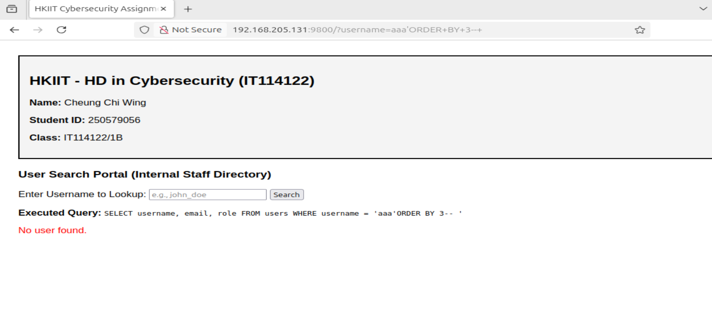
This query has 3 column
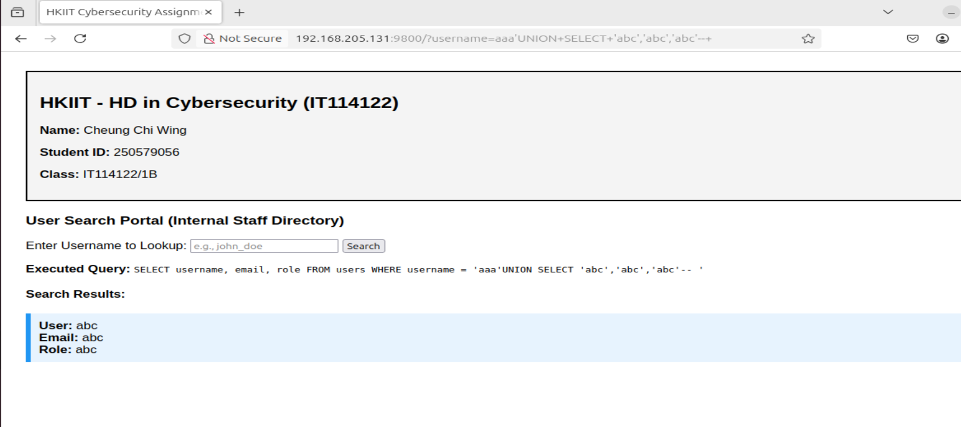
3 column is a string value
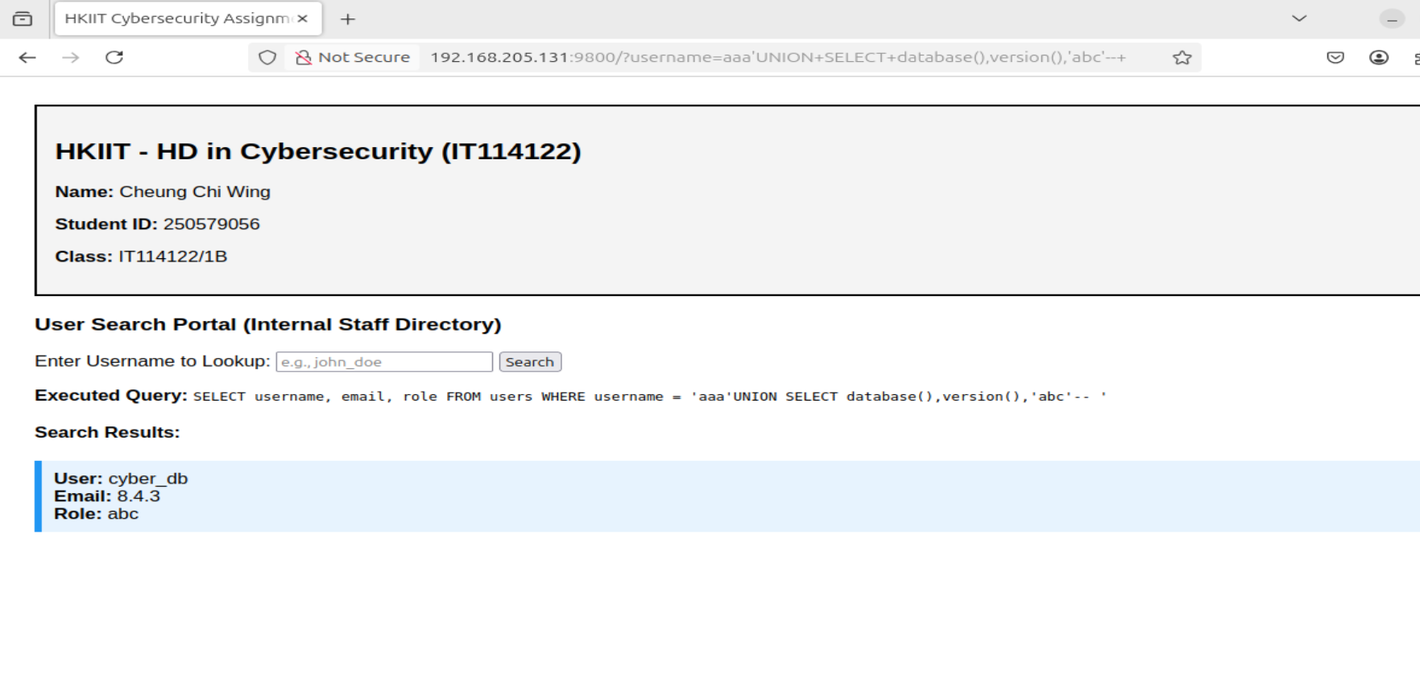
The database is cyber_db
And version is 8.4.3

Task C
The Fix:Prepared Statements
the database engine complies the SQL query structure before the input is inserted.It’s treated as a parameter.Even if atacker enters ‘ OR ‘1’=’1,it will only searches username string that matches the sequence

Refined code:
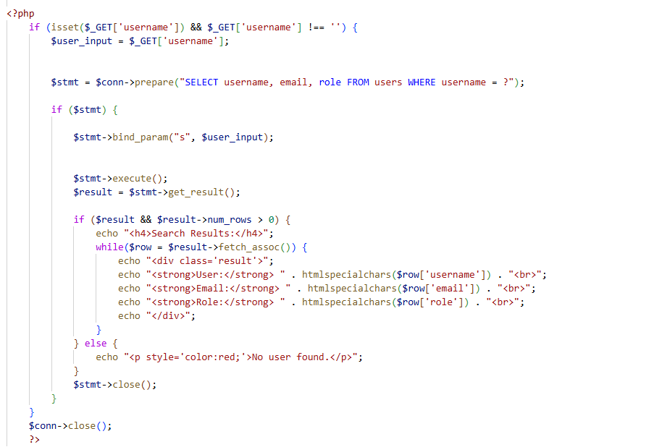

Task D
Input payload: ‘ OR ‘1’=’1
URL:http://192.168.205.130:9800/Patched_index.ph p?username=aaa%27%20OR%20%271%27=%271
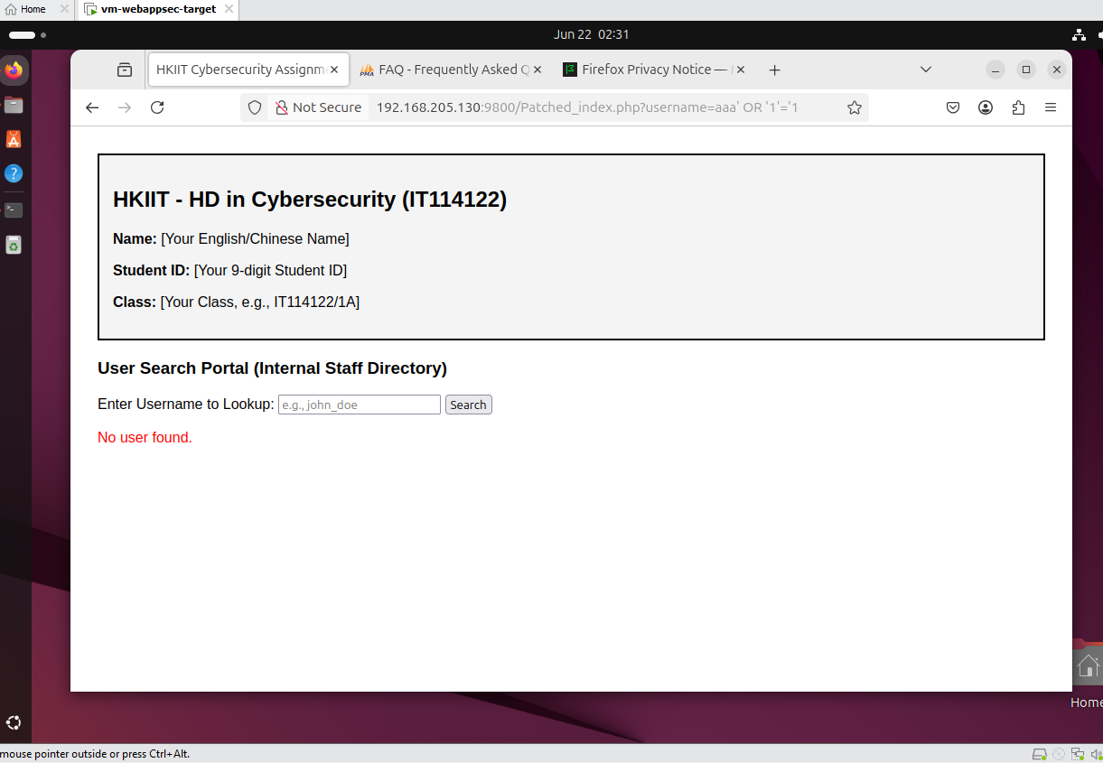
Explanation: The application is no longer interpreting the quotes an exit out of string data type.It check users table for a literal username equal to ‘ OR ‘1’=’1 .Since no such user exists,the application safely fails to return data,proving the vulnerabillty is resolved

